Understanding De-embedding

* DUT(device under test) can be both coaxial or embedded. For coaxial DUTs measurements are straight-forward by connecting the ends or ports to a VNA using high quality connectors.
* By calibrating at the DUT ends of the cables, their influence can be removed and reference planes moved to ends of the DUT.
* This calibration is usually done by adding calibration standards to DUT ends of coaxial cable.
* Sometimes we cannot do this process because DUT is embedded in a structure like a PCB.
* Fixture compensation is done because at high frequencies we encounter non-linearities in functioning of the fixtures attached to the DUT.

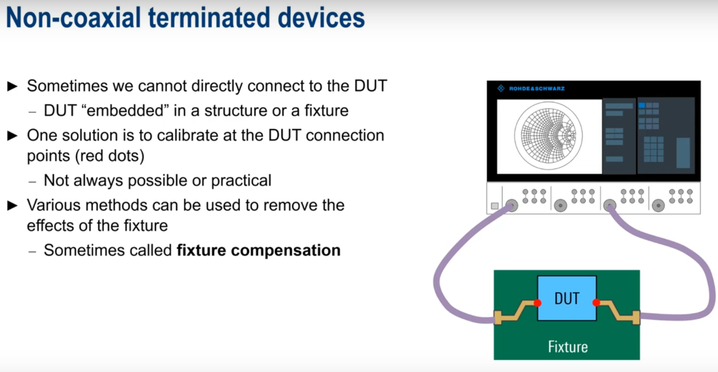

* Using **port offset or port extension** - we consider the yellow fixture to be part of the cable from the VNA with a defined delay and loss which can either be entered by the user or calculated automatically by the VNA. This is an easy configuration with low accuracy because we don’t consider reflections,crosstalk etc. Here we are basically considering the fixture to be an ideal transmission line.
* Using **direct compensation** - Similar to port offset but here we don’t assume fixture to be an ideal transmission line and instead, we measure the frequency dependent transmission characteristics of fixture. Best results are obtained by using open and short at ends of fixture.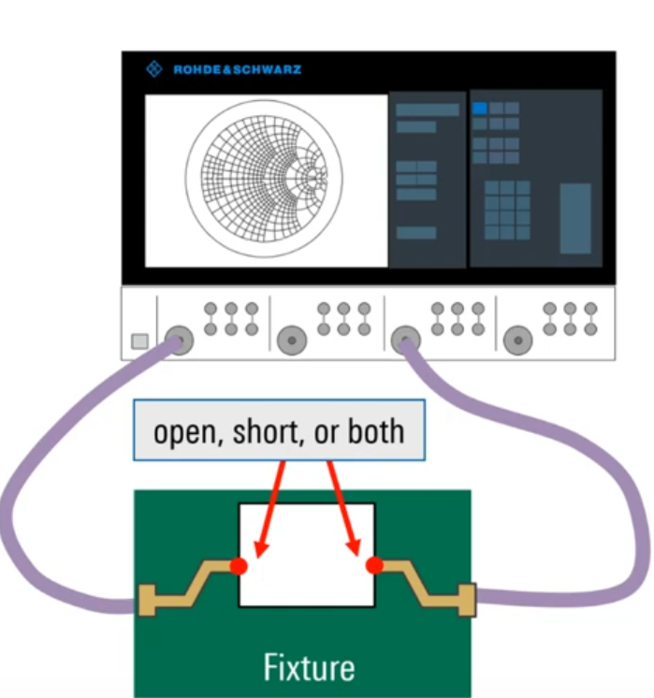Like port extension, it works well only at lower frequencies of a few GHz and below.
* Using **fixture calibration** - directly characterize the fixture. Harder to implement.

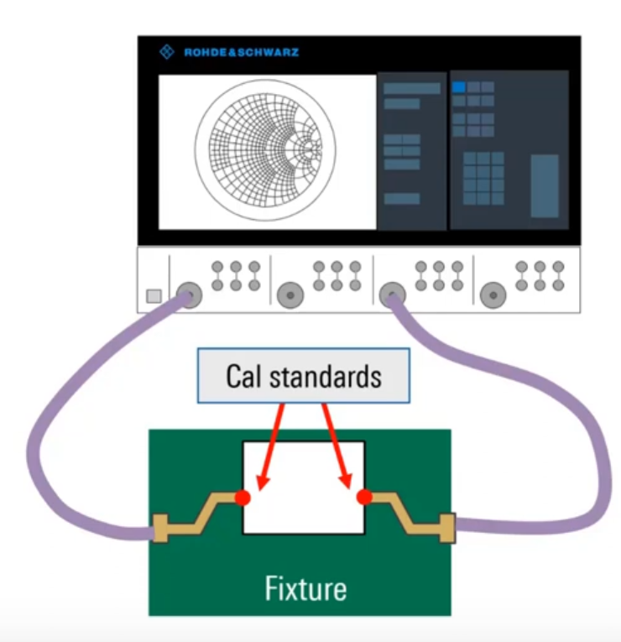

* **TRL** - Calibration standards are implemented as test coupons on the PCB. Very good accuracy if the coupons and dut have similar impedances.
* De-embedding obtains and uses S-parameters to compensate for the effects of the fixture. Model the fixture as additional “networks”. Various mathematical algorithms can be used for modeling.This is the most accurate method of fixture compensation but it is hard.

Understanding VNAs - cable impedance measurements

* Coaxial cables usually have an impedance of 50 ohms. They consist of an inner conductor, a conducting outer shield and an insulator between them. The characteristic impedance is a function of diameters of conductors and dielectric constant of the insulators.
* Quarter wave impedance transformer is a transmission line that is a quarter of a wavelength long and terminated with a known impedance.
* We can put in some easy equations and use this quarter wave transformer to calculate the impedance of the cable.

Basic Spectrum Analyzer operation

* These are frequency domain devices that make power vs frequency measurements.
* The basic configuration parameters are center/span, reference level, resolution bandwidth and video bandwidth.
* Span - To define a frequency range for operation, instead of defining start and stop values we usually define center frequency and span. This allows us to change span and easily zoom in to the graph.
* Reference level - It is the top edge of the display and represents the maximum input power we can expect. We usually define this to be slightly higher than the highest level of our signal. Having a very high reference level decreases our ability to see small changes. If we set our reference level too low, the top part of the graph will get cutoff and it can also negatively impact our results because the reference level tunes the input attenuator which protects the internal circuitry from high power.
* Resolution bandwidth can be thought of as a window that goes over the signal and measures the level as it goes. It is actually a gaussian shaped window. Actually the window is stationary and the signal moves across it but thinking the other way doesn’t hurt.
* Resolution bandwidth affects our ability to resolve closely spaced signals.

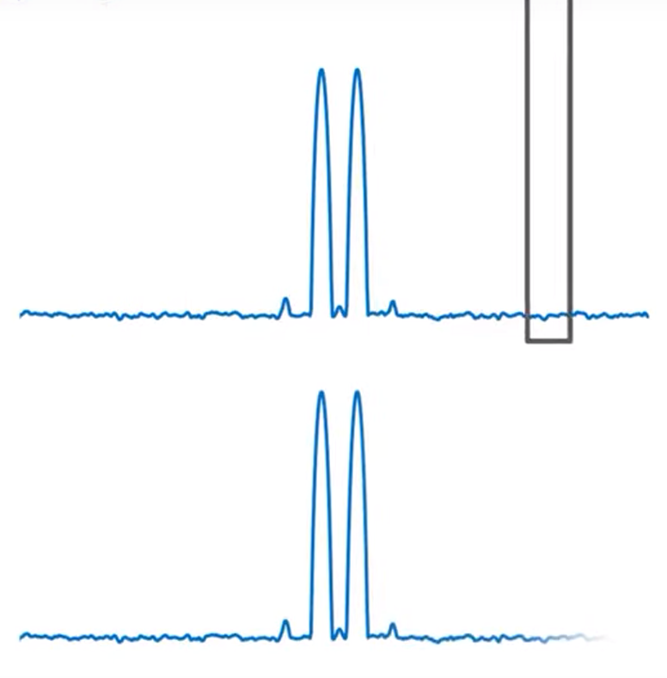

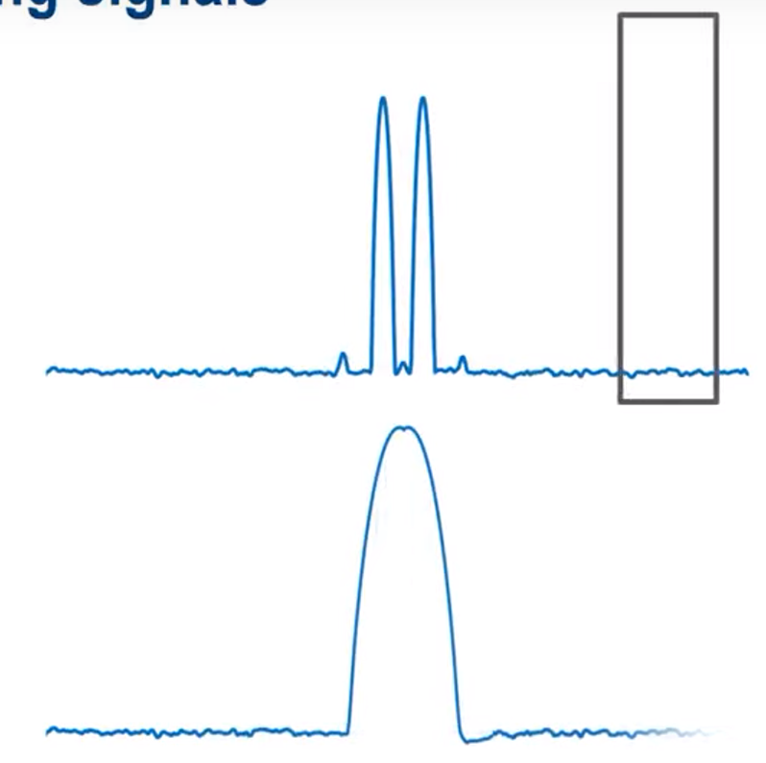

* Also, decreasing resolution bandwidth by a factor of 10, reduces the noise floor by about 10 dB.
* Then it looks like we should always choose a very narrow bandwidth but narrow filters take longer to settle than wide filters. At lower bandwidths, you must sweep slower to avoid frequency and amplitude errors. Most analyzers compute sweep time automatically based on span and bandwidth.
* Choosing the bandwidth is experimental and a trade off between speed and accuracy.
* Video Bandwidth(VBW) is a filter used to average or smooth the displayed trace. It only affects the display and not the way the signal is measured unlike resolution bandwidth.

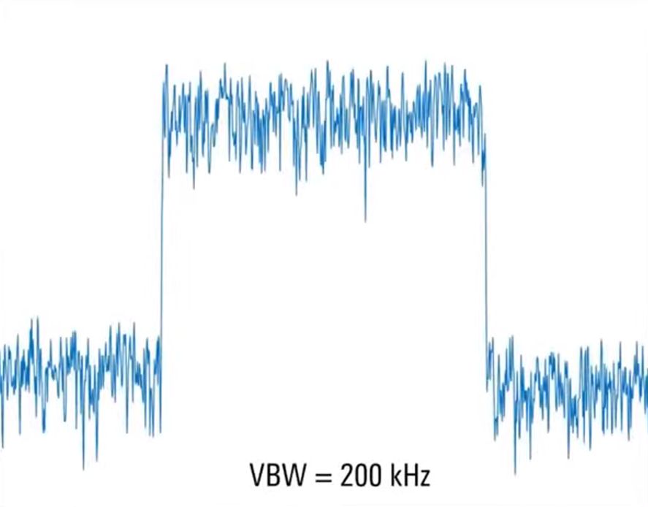

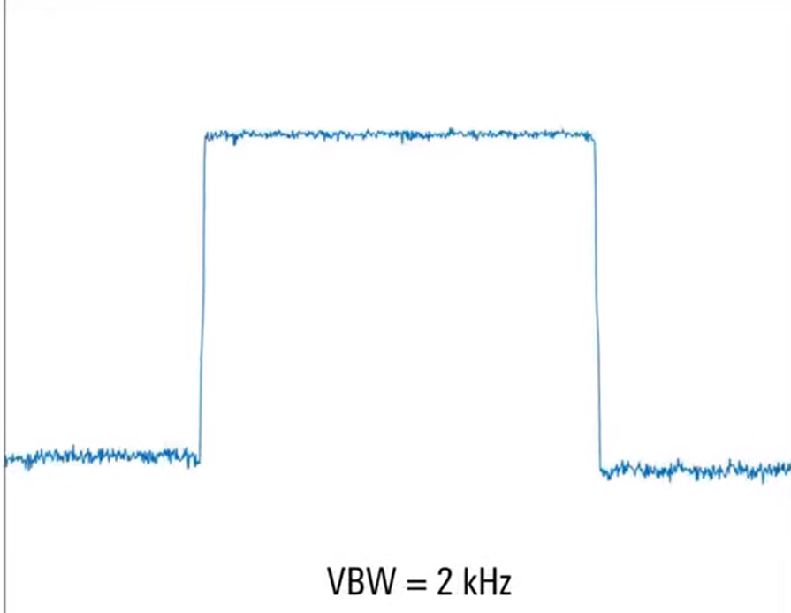

* Video bandwidth only changes the appearance of a signal so its value really only depends on the application. Most spectrum analyzers automatically choose this. Narrower VBW means longer sweep time.

Understanding Third Order Intercept

* Linearity: the output of a device is directly proportional to its input. Devices are typically linear only over a certain power range. Beyond which, they become non-linear and cause distortion in the form of harmonics and intermodulation products.
* Harmonics are copies of the signal appearing at integer multiples of the fundamental frequency. Amplitude of a harmonic usually decreases as the harmonic order increases. Harmonics are almost always undesirable.

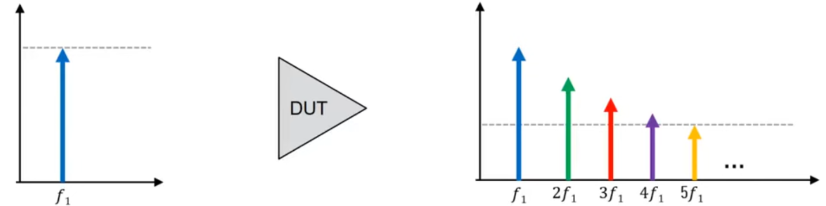

* Intermodulation occurs when DUT has 2 input signals and output contains a mix of these two signals producing new signals at the sum and difference of their two frequencies.
* Higher order products occur when signals mix with each other’s harmonics creating signals with 2f1+f2, 2f1-f2, f1+2f2 etc.
* The order of harmonics and intermodulation is the sum of their unassigned coefficients.

For example, the order of 2f1 is 2. Order of f1+f2 is 2. Order of 2f1+f2 is 3, Order of 2f2-f1 is 1 etc.

* By applying a bandpass filter we can get rid of most of these intermodulation and harmonic terms but two of the combinations - 2f1-f2 and 2f2-f1 are very close to f1 and f2. So we are interested in removing them.

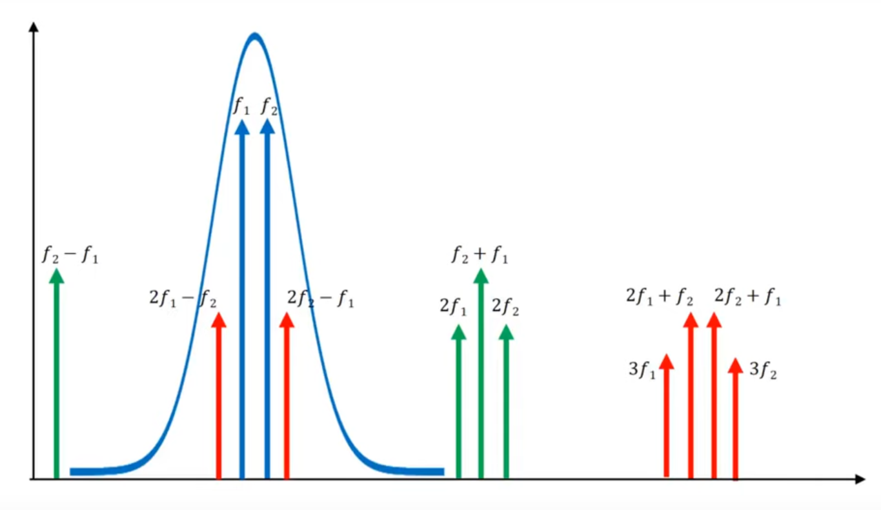

* Besides the filtering issue, for every 1 dB increase in fundamental signal, the third order unwanted products grow by 3dB which means that at some input power,the gains of actual signal and bad signal will become equal and then bad signal will dominate but in reality, this doesn’t happen because real world devices have a limit on maximum output power irrespective of input so both plots flatten out. When the graphs flatten out, device is said to be in compression

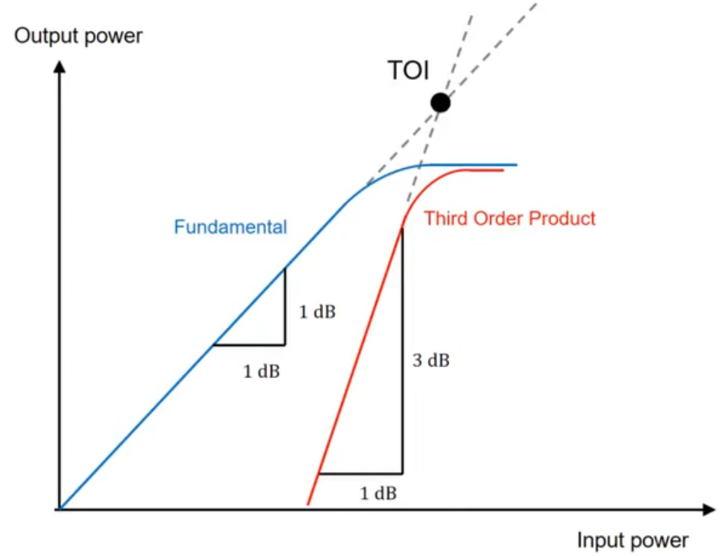

* The point mentioned as TOI is called third order intercept and is a good way to measure linearity. It is a theoretical point. The higher the TOI, better the linearity and lower the level of intermodulation distortion.
* While measuring for TOI, take precautions to avoid the intermodulation products being created by the analyzer. Add attenuators or use directional couplers to avoid mixing of the 2 signals before they go into the DUT.
* To check if the IMD is being generated in the analyzer, add an attenuator of about 10 dB in front of DUT before connecting to the analyzer. If distortion decreases, analyzer is causing IMD and if distortion stays the same IMD is being created externally.
* Linearity decreases with increasing frequency.

Understanding spectrum analyzers - DANL

* Even with no input power, the analyzer will still display a trace at the bottom of the screen representing the internal noise of the analyzer.
* DANL is the average noise level displayed on a spectrum analyzer with the input terminated with a matched load. It is normalized to a 1 Hz bandwidth.
* A low DANL is usually desirable because signals with amplitudes less than DANL cannot normally be measured.
* Noise figure quantifies how much noise a device adds to a signal passing through it. It is largely a function of spectrum analyzer architecture. Lower the NF, lower the DANL.
* Narrower resolution bandwidth filters reduce the amount of noise energy leading to lower DANL. Decreasing RBW by a factor of 10 reduces the DANL by 10 dB but again lower RBW increases sweep time.
* Reducing input attenuation reduces DANL. Preamplifiers increase signal level so higher the gain of preamp, lower the DANL. But be careful because excessive preamp gain can lead to compression which leads to inaccurate measurement results and/or distortion.
* Noise cancellation in spectrum analyzers terminates the input, measures its internal noise and then subtracts the internal noise from the input signal. This can reveal signals previously below the noise floor.
* DANL may not always appear flat. We may see it as ‘steps’ or ‘ramps’ in DANL at different frequencies. This can be caused by many things such as different setups per band or frequency response correction etc.

Understanding Spectrum Analyzers - noise figure

* SNR is the ratio of power of a signal to power of its adjacent signal.
* Noise factor is the linear ratio of input SNR to output SNR. It is usually converted into dB and called a noise figure. Lower noise figures are more desirable. It is often easier/ more cost-effective to improve NF than to increase transmit power or antenna size.
* We measure noise-figure using a network analyzer and a wideband noise source as the input to the DUT. The source produces a known amount of noise in terms of its ENR.
* The procedure is called the Y-factor method.
* The difference in the output of the DUT with the noise source on and off is called the y-factor.
* We usually do a calibration step with just the noise source before plugging in the DUT to find out the noise factor of the analyzer.
* An internal or external preamp is almost always required for accurate NF measurements particularly when DUT has low NF and low gain because the noise figure of the analyzer itself is often the largest contributor to measurement uncertainty.
* When the preamp is on, DANL reduces.
* COmbined NF of cascaded components can be calculated using gain and individual noise figures with the help of Friis equation

Understanding Spectrum Analyzers - Dynamic Range

* Attenuation can be used to measure high level signals when necessary and Amplification can be used to help measure low level signals. But measuring both high and low level signals at the same time can be challenging. But we often have to measure low level signals in the presence of high level signals.
* Dynamic range is defined as the difference between highest and lowest amplitude of signals that can be measured accurately at the same time. It is measured in dB and a higher value of dynamic range is desirable.
* Important factors on the lower end are DANL and phase noise. IMportant factors of the higher end are maximum input power and compression.
* Phase noise is a short time variation in frequency stability which creates noise sidebands above and below a carrier. Often created when a signal is mixed with a noisy oscillator.
* This phase noise can increase DANL.

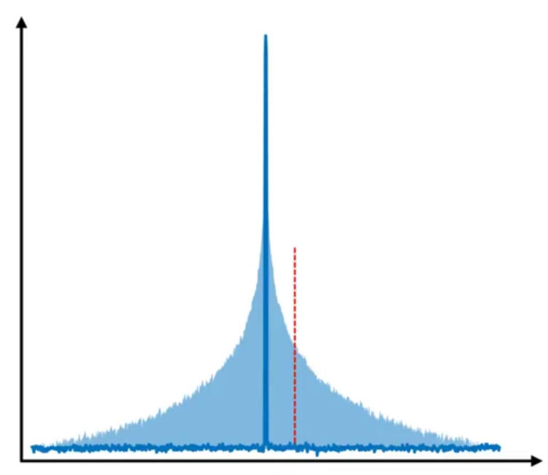

* Spurious signal are the harmonics and intermodulation products created due to compression
* Spurious free dynamic range(SFDR) is the amplitude difference between the fundamental and the largest spur. It is a metric used when dynamic range is primarily limited by the presence of a large spurious signal.

Understanding Zero Span

* When we set span to zero, the resolution bandwidth filter gets fixed at a particular frequency and gives us power vs time at that frequency.
* This is somewhat similar to an oscilloscope because it gives us amplitude vs time. But an oscilloscope gives us voltage vs time on a linear scale while zero span gives us power vs time on a log scale.
* To choose between zero span and oscilloscope, keep in mind that a spectrum analyzer has a higher dynamic range while an oscilloscope has a higher bandwidth.
* For zero span, fix resolution bandwidth to be slightly more than width of measured signal.
* Rule of thumb for video bandwidth is to have it more than resolution bandwidth to avoid excessive smoothening of signals.
* Zero span is used in audio demodulation by placing a marker on the signal of interest. Name it demod and then choose AM or FM and an appropriate resolution bandwidth.
* In zero span there is no sweeping so the demodulation time is basically infinite and the output audio is continuous.
* We can also use zero span to measure channel power on a spectrum analyzer by setting frequency to center channel and selecting appropriate RBW. It can also be used to see power vs time on pulsed or time-varying signals.

Understanding Occupied Bandwidth

* Measuring bandwidth is important to see if there are any faults in the system and to make sure we meet regulatory standards.
* Occupied bandwidth is defined as the bandwidth(in Hz) that contains a given percentage of the total signal power. (usually 99 percent)
* Occupied bandwidth is usually less than nominal channel bandwidth.
* So why do we need channel bandwidth → to help the analyzer correctly set span,RBW etc.
* Signals are generally given frequency ranges or channels.
* Channel power is the sum of all power in a given channel. The power of the signal that leaks beyond the channel is measured using ACLR(adjacent channel leakage ratio)
* Channel power can be measured using RF power sensors directly but only when it is the only signal present in the input. We can also use zero span. Most analyzers can directly measure channel power by summing the power given a channel. This is done by summation and hence called integration method.

Understanding Noise Power ratio

* Wider bandwidth systems frequently use multiple carriers for example, in cable systems, satellites etc.
* Mixing of these carriers can cause IMD. If the IMD falls in the channel it ruins our SNR and if it falls outside, it ruins someone else’s SNR.
* Third intercept is not a great way to measure IMD for multi carriers. Instead, we use something called noise power ratio.
* We take the entire channel, cut out a part which doesn’t contain signals. Now send the notched signal as input to DUT and see the notch fill up with IMD(spectral regrowth). Measure the new notch depth.
* Noise power ratio is the ratio of carrier power to notch power. Higher NPR means less IMD.
* We need to make the notched signal as realistic as possible and the notch needs to be as deep as possible and we may also need multiple notches. We may also need to change the position of the notch to test IMD at different points.
* The signal can be generated using an analog generator and a notch filter.
* We may also use a vector signal generator.

Understanding CCDF

* Three statistical power measurements -

1. Probability density function(PDF) - Describes the relative likelihood that measured power takes on a given value.
2. Cumulative Distribution Function(CDF) - Got by taking PDF and integrating over the entire function. Helps when we want to know what percentage of time a signal’s power is below a certain value.
3. Complementary Cumulative distribution function(CCDF) - (1-CDF) Tells us the percentage of time a signal’s power is at or above a certain value.

Understanding Harmonic Distortion Measurements

* We usually measure harmonics using zero span mode on the analyzer, fixing at fundamental frequency and then the harmonics.
* Harmonic distortion is reported either as the amplitude of individual harmonics relative to the fundamental in units dBc or as the power in multiple harmonics relative to fundamental called total harmonic distortion(THD).
* THD is usually automatically calculated by a spectrum analyzer given the number of harmonics to include in the measurement.

Understanding Phase Noise fundamentals

* Oscillators generate a signal at a given frequency. The frequency or phase stability of an oscillator is very important but of course nothing is perfect so we have errors.
* A real or non-ideal oscillator creates signals having amplitude and phase that vary with time.
* Phase noise describes variation in short-term(seconds or less) frequency stability.
* Phase noise can cause power of a signal to spill out of its channel leading to interference and spectral regrowth.
* Phase noise in local oscillators reduces selectivity and sensitivity of the receiver.
* Phase noise can cause rotation of constellation points in communication channels using techniques like QAM. Too much rotation can cause one symbol to be mistaken for another leading to a higher bit error rate.
* We use a phase noise analyzer to detect phase noise and other parameters related to oscillators such as AM noise, spurious, etc.
* Phase noise sidebands are usually symmetrical about carrier frequency.
* Spot noise is phase noise measured at specific frequency offsets.

Understanding Voltage Controlled Oscillators

* An oscillator whose output frequency can be varied or controlled by an external voltage is called voltage controlled oscillator.
* Tune voltage may change continuously or in discrete steps.

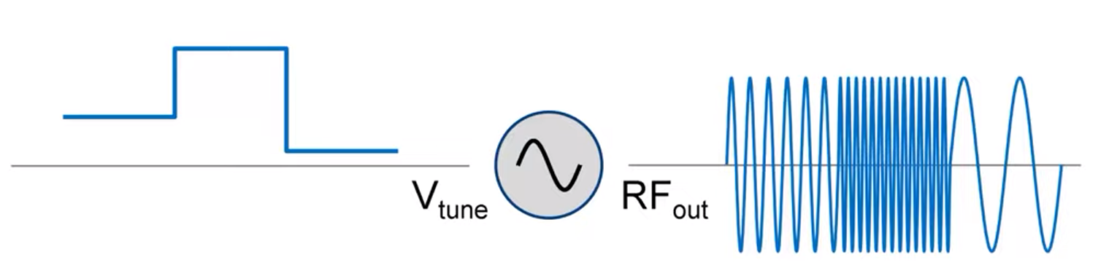

* Common applications of VCOs are in phase locked loops/synthesizers, communication systems such as FM and FSK/frequency hopping and radar(especially chirped/FMCW)

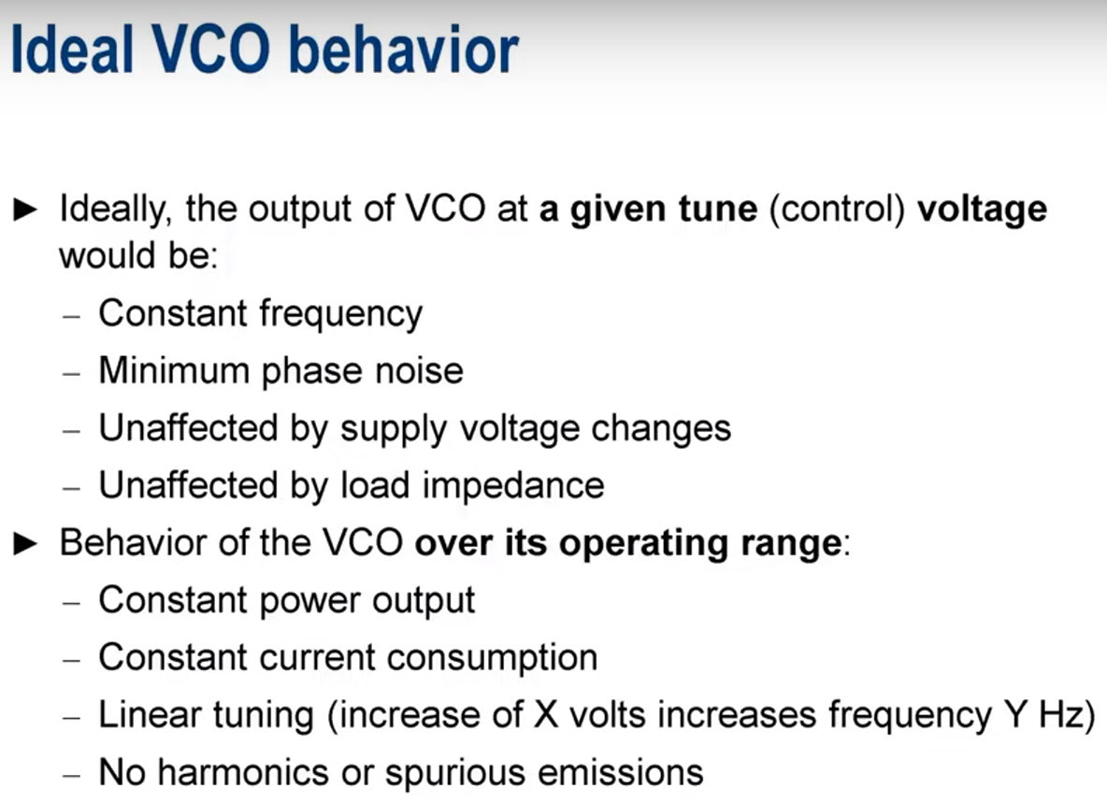

* Most important requirements in characterization of VCOs are stable, high-precision fixed and variable voltages. And the ability to precisely measure frequency, power, phase noise etc. as voltages are changed.
* Phase noise testers usually incorporate VCO characterization functionality which automatically measure common VCO characteristics.
* We check frequency pushing by keeping a constant tune voltage and varying the supply voltage over a range to see changes in output frequency.
* Frequency or load pulling is measured by attaching a coupler and a variable impedance to the VCO and seeing how output frequency changes with changing load impedance.
* Tuning sensitivity is the change in output frequency per unit change in tuning voltage. Ideally this should be as constant as possible across the tune voltage range.
* We also measure output power and current output vs frequency.
* All VCOs generate harmonics. Some VCOs have filters to lower the harmonic power.Harmonic levels are often reported relative to the level of the carrier/fundamental.

Understanding Pulsed signal generation

* A pulsed signal is a signal whose amplitude alternates between zero and non-zero levels.
* They usually have 3 main characteristics - pulse envelope, pulse timing and pulse modulation.
* Pulse envelope can be defined using pulse width, rise time, fall time, overshoot, droop, ripple etc.

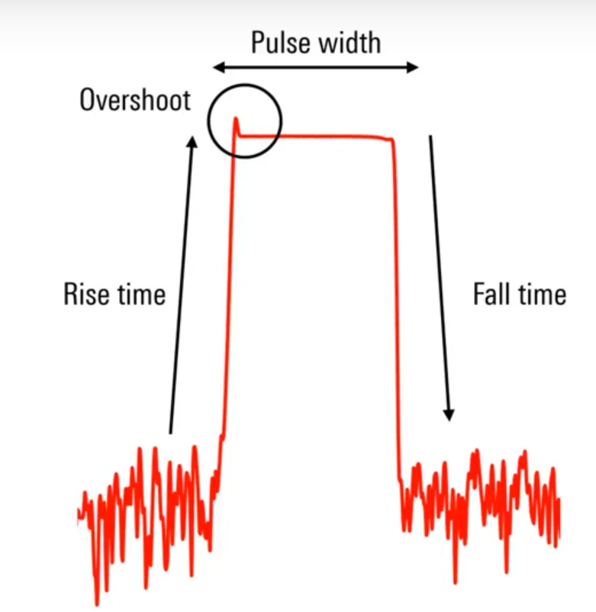

* Time between pulses can be uniform or non-uniform.
* Uniformly spaced pulses can be defined by pulse repetition interval(PRI) or pulse repetition frequency(PRF).
* Pulse envelope only shows the magnitude of the RF carrier over time. In an unmodulated pulse, frequency and phase of the carrier are constant during the duration of the pulse.
* In modulated pulse, the frequency and/or phase of the RF carrier change during the duration of the pulse

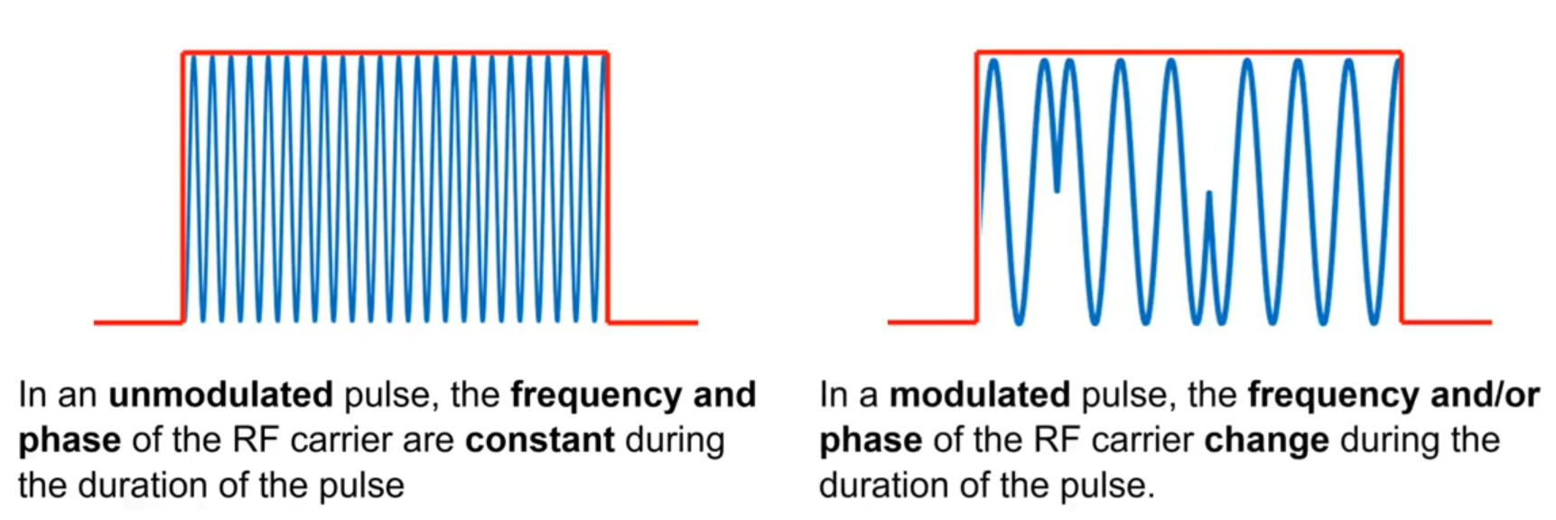

* Pulse modulation is most important in radars.
* Short pulses give better range resolution but are more difficult to implement. Pulse modulation enables the use of longer pulses to get the same results as with shorter pulses. Hence, pulse modulation is also called pulse compression.
* Analog signal generators can create unmodulated pulses.These pulses have excellent spectral purity.
* Vector signal generator does everything that an analog signal generator can do but can do signal modulation as well.

Understanding Signal Generators

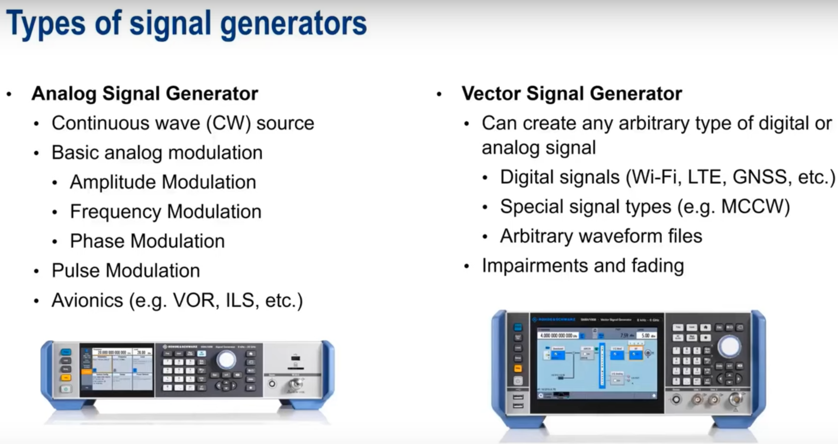

* An analog signal has a magnitude alone but a vector signal is defined by both a magnitude and a phase. Vector signals are used to send digital information.(QPSK)
* For vector signals, instead of sending a magnitude and a phase, we send two magnitude values I and Q. (I as in In-phase or real part and Q as in Quadrature or imaginary part)
* A vector signal generator produces signals using IQ values. IQ values can be provided by an internal generator or an external source. There is no industry-wide standard for IQ data format.
* The term baseband is used to refer to IQ signals before they are converted to RF.
* Vector signal generators are used to generate signals for wireless communications, digital broadcast, GNSS, multi-antenna systems(MIMO), and beamforming.
* Generator bandwidth represents the ‘maximum width’ of the generated signal.
* Wide bandwidths present special challenges such as maintaining spectral flatness i.e, making sure that the generator does not introduce amplitude errors over wide bandwidths. We can ensure this by placing an internal level sensor in the analyzer.
* IQ data can be provided to the baseband over external analog and/or digital IQ inputs. Baseband data can also be output without being upconverted to RF.
* ARB file or arbitrary waveform file is an externally created file that contains baseband IQ values. This can be created in matlab but is very time-consuming and difficult. There are also software applications to create these ARB files. ARB files give us complete flexibility in defining waveforms and parameters using IQ values. But the memory requirement of the machine limits waveform length.
* Vector analyzers also allow us to create internal ARB files. These are created on the generator itself using the GUI. It gives easy configuration of modulation type and parameters. They can be stored in generator memory or saved as a file. It is significantly easier than external waveform creation.
* Markers can be used to indicate when a waveform(or part of a waveform) is being generated.
* Real Time signal generation is based on configured parameters such as modulation type, modulation parameters, and data(contained in a file, pattern or as PRBS). PRBS is a pseudo random bit sequence which is a non-repeating bit sequence. Because the signal is being generated in real time, long sequences can be generated. Real time requires low memory because we are not creating and storing sets of IQ values. We use real time signal generation in bit error rate tests.
* Real time signal generation is needed to simulate GNSS because we need to simulate signals from multiple satellites for a long time because receivers take time to lock on the signal and receiver testing involves tracking satellites for long periods of time(minutes, hours, days).
* The last block in the vector signal generator is the RF block where we specify the signal characteristics such as frequency, level, analog modulation. It also allows us to step or sweep through frequencies or levels for various types of testing.
* Impairments are components that allow us to mimic real world signals. For example, fading, noise/interferers and IQ impairments.
* The different types of baseband impairments are

1. Noise(AWGN)
2. CW interferers
3. Impulse Noise
4. Phase Noise

* AWGN - Additive White Gaussian Noise. Additive means it adds to our signal. White means constant power over all frequencies. Gaussian is how power changes with time. This helps testing under real-world conditions. It helps create a controllable SNR signal for receiver testing, bit/block error rate testing. It also helps produce a noise-only signal.
* CW(continuous wave) interferer creates an unmodulated carrier either within or near the frequency range of the actual signal. Power level can be adjusted according to the power level of the signal.
* Impulse noise has an ‘on-off’ or bursty pattern. Many real world interference noises are sources of impulse noise. Unintentional: spark plugs, motors etc. and intentional: radar or bursty modulation types. It is defined using pulse width, number of pulses and interval between pulses.
* Phase noise is short term variations in the frequency of a signal. Adding phase noise can allow us to determine the maximum acceptable level of phase noise in the components, systems etc.
* Rice fading - fading generally constant and rayleigh fading - occasional deep fades.
* I and Q signals should be exactly 90 degrees apart and have equal amplitudes. Imperfection in the IQ modulator/demodulator can lead to errors. These errors are not a function of propagation but of the components. Vector generators can create IQ errors like quadrature offset(angle not exactly 90 degrees) and Gain offset(magnitudes not exactly equal) for testing.

Understanding Signal Integrity

* Signal chain consists of three parts - transmitter, channel and receiver.
* Most digital data is transmitted as square wave signals which consist of multiple frequency components. Good digital data transmission requires constant amplitude change for all frequency components and constant time shift/delay for all frequency components. If either of these is not constant, it can lead to signal distortion.
* Signal integrity is the ability of a system to transfer (data)signals without excessive distortion.
* Signal integrity becomes more important at shorter rise time(higher frequencies).
* SI is an important concern in high speed digital design.
* In an ideal channel, the received signal has different magnitude and time-shift compared to transmitted signal due to attenuation and propagation time but signal ‘shape’ remains same.
* In a real channel, frequency dependent changes can change the ‘shape’ of the received signal.
* Usually higher-frequency components are attenuated more than lower-frequency.

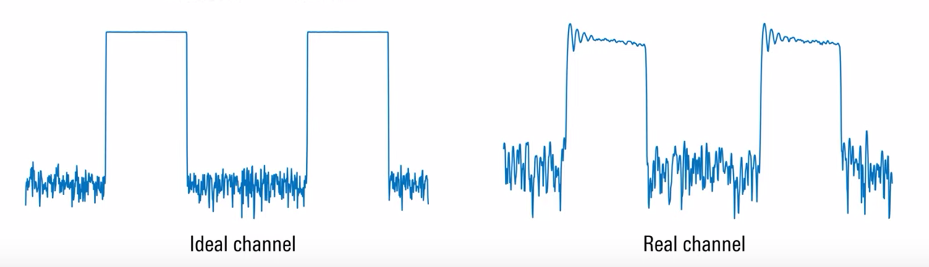

* Channels can have different physical formats such as PCB trace, connectors between boards and cables between components/systems.
* To avoid degradation, the signal should see a constant impedance along the path. If there is an impedance change or mismatch at some point, it will lead to reflection and hence, distortion. Sources of mismatch on PCBs are changes in trace dimensions/geometry, improper terminations/unterminated stubs, hole sizes, pad sizes, discontinuities with device pins, variation in board materials etc.
* Attenuation usually increases with frequency. Some sources of frequency-dependent loss are conductor resistance, dielectric losses(depending on choice of PCB material). Skin effect is another form of loss.(High frequency signals travel near the outside of a conductor).
* Coupling of energy between conductors usually caused by mutual inductance and/or mutual capacitance is called crosstalk. We use the terms aggressor and victim. Near end crosstalk happens near the transmitter of the aggressor and far end crosstalk happens away from the transmitter of aggressor. Faster rise times create greater levels of crosstalk.
* Crosstalk can be minimized by increasing separation between traces. Minimizing parallel run lengths and placing conductors close to the ground plane.
* Jitter is defined as the variations in the timing of the signal. Signal transitions must occur between sample times. But if this doesn’t happen, it can cause undefined or incorrect values at sample times leading to bit errors.
* Simulations on computer softwares are used to check signal integrity before actually designing the PCBs and systems.
* Eye diagrams assess the quality of transitions and provide information such as rise time, amplitude, noise , offset etc.
* As the signal goes through the channel, the eye diagram narrows both vertically and horizontally and if signal integrity is bad, eye closure may cause difficulty in retrieving the signal.

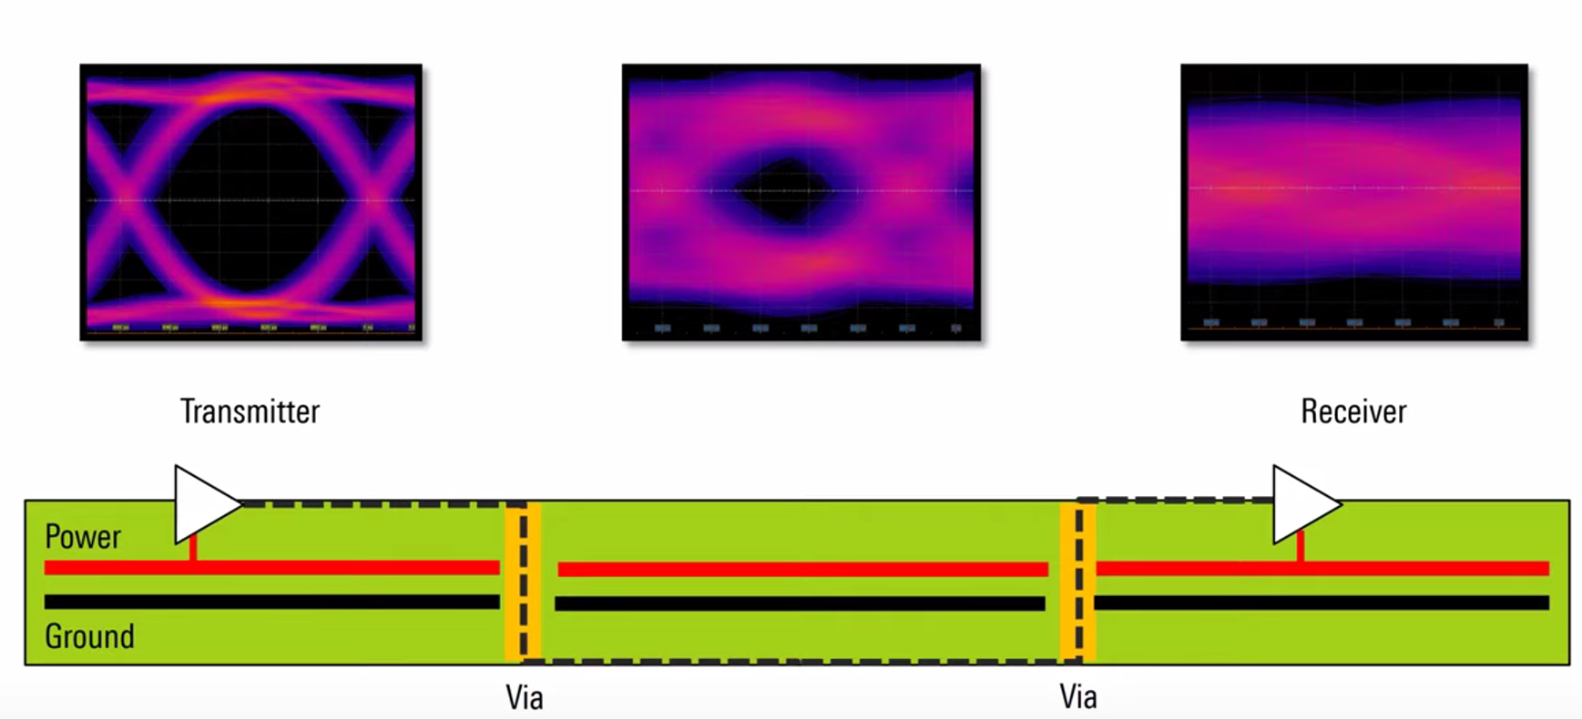

* The bandwidth of an oscilloscope is defined as the frequency at which the measured amplitude of a sinusoidal input signal is attenuated by 3 dB.
* Insufficient bandwidth causes wrong amplitude reading, waveform distortion and inaccurate rise time measurements.
* Pure sinusoids can be measured up to or beyond the scope of the bandwidth but for other analog applications, we want our bandwidth to be 3 times that of the maximum frequency of the wave. This 3x rule also applies to low speed serial decoders such as UART, SPI, I2C etc.
* For digital signals that are rectangular with very short rise times and sharp edges, we use a bandwidth that is 3-5x the highest clock frequency because square waves are created by odd harmonics and this allows us to include the 3rd and 5th harmonic.
* Attenuation usually has two general ‘shapes’ - gaussian and brick wall
* Gaussian shape yields faster rise times.
* Flat/brick wall shape attenuate in-band signals less than gaussian.
* Passbands are often not completely flat. Passband ‘flatness’ can be quantified by frequency magnitude response which is typically between 0.5 and 1 dB.
* Rise time is defined as the time for the signal to go from 10 percent to 90 percent value.
* A measurement system consists of an oscilloscope and probes(cables/fixtures), The system bandwidth is a function of individual bandwidths of probe and oscilloscope.
* Probe bandwidth should be at least 1.5 times the scope bandwidth.
* Intentionally reducing bandwidth is done to remove high frequency noise. This can be achieved using inbuilt analog filters, digital filters or high definition mode.
* Effective number of bits(ENOB) is a hardware limitation to vertical resolution. Primary reasons for this limitation are noise and non-linearities. It reduces ability to accurately measure the input waveform.
* 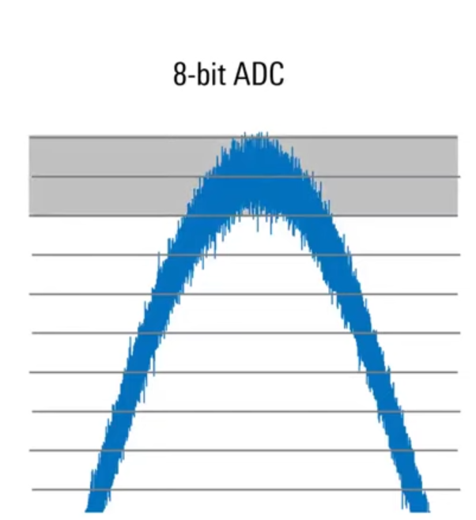
* At the top, ADC may read the value of either the highest or last but one level because of the noise. This makes an 8-bit ADC into a 7-bit ADC. Therefore we use ENOB to represent real world ADC performance. ENOB is usually not an integer and is less than k for a k-bit ADC(ideally equal to k).
* ENOB is a function of the entire system inside the scope and not only the ADC.
* ENOB is lower at higher frequencies.